

Project Interim Report
On

Hotel Room Reservation Application

RU-100-05-00018

JAVA for Object-Oriented Solutions

SESSION: 2025-2026

Submitted By
Bhoomi Shrivastava
RU-25-10395

Bachelor of Computer Application
with Data science in association with Google

Under the Guidance of
Mr. Harsh Multani

SCHOOL OF COMPUTER SCIENCE AND ENGINEERING
RUNGTA INTERNATIONAL SKILLS UNIVERSITY
BHILAI, CG
(April 2026)

Abstract: Hotel Room Reservation Application
The Hotel Room Reservation Application is a Java-based software designed to simplify the management of hotel bookings and room availability. Developed using Object-Oriented Programming (OOP), the system organizes data into a structured format that mimics a physical hotel building using 2D Arrays to represent floors and rooms.
In the modern hospitality sector, manual tracking of room occupancy is inefficient and leads to overbooking errors. This project is needed to provide a reliable, digital way to monitor which rooms are free and which are occupied in real-time. By automating this process, the system ensures that guest information and room statuses are always accurate and easy to access.
The application allows users to browse rooms across different floors, book available rooms, and cancel reservations when needed. A key feature of the project is the use of an Interface for billing, which calculates the total cost of a stay based on the room's daily rate and the number of days booked. This ensures a transparent and error-free financial summary for every guest.

Introduction
The Hotel Room Reservation System is a Java application designed to simulate the core operations of a modern hotel. The project focuses on managing room inventory, tracking occupancy, and processing guest bills efficiently. By using Object-Oriented Programming (OOP), the system creates a digital twin of a hotel building, making it modular, scalable, and easy to manage.
The project is structured into three primary components:
- Room Class: This serves as the blueprint for every room, storing essential data like the room number, type (Single, Double, or Deluxe), and whether the room is currently vacant or occupied.
- Hotel Class: This class manages the entire building using a 2D Array (Room[][]). This structure allows the system to represent the hotel floor-by-floor, where the first index represents the floor level and the second represents the room number on that floor.
- Service Interface: This defines the "contract" for billing. It ensures that any class handling payments follows a specific logic to calculate the total cost based on the duration of the stay and the daily room rate.
The system provides essential features such as real-time booking, where a room's status is automatically updated to "Occupied," and a cancellation feature that returns the room to "Available" status. This automation reduces manual paperwork and prevents errors like double-booking.

Objectives
- Organize Room Records: Categorize rooms by type and price across multiple floors.
- Implement 2D Arrays: Use matrix logic to handle a complex building layout efficiently.
- Apply Abstraction & Interfaces: Use a Service interface to separate the billing logic from the room management logic.
- Automate State Changes: Ensure the system automatically toggles availability status during booking and checkout.
- Reduce Manual Effort: Eliminate the need for handwritten ledgers by providing a quick digital summary of the hotel's status.

Scope
The Hotel Room Reservation Application is designed as a focused management tool for hospitality services. While it is currently a console-based program, its architecture is built to support future expansion into a professional-grade system:
- Target Use: This project is ideal for small hotels, guest houses, or hostels that need a simple way to track room occupancy and generate bills without expensive software.
- Architectural Flexibility: By using a Service Interface, the system can easily be updated to include different billing models, such as seasonal pricing, loyalty discounts, or corporate rates.
- Future Enhancements: The system is ready to be upgraded with:
  - Persistent Storage: Using a Database (SQL) to save guest records and room history permanently.
  - Interactive Interface: Adding a GUI with a floor-plan view where rooms change color based on availability.
  - Advanced Booking: Implementing a Calendar System to allow guests to book rooms for specific future dates.
  - Online Integration: Connecting the backend to a web or mobile application for remote guest bookings.

System Requirements
Hardware Requirements:
- Processor: Intel Core i3 or higher (or equivalent).
- RAM: 4GB minimum (8GB recommended for smooth IDE performance).
- Storage: 200MB of free disk space for project files and JDK.
Software Requirements:
- Operating System: Windows 10/11, macOS, or Linux.
- Language: Java Development Kit (JDK) 8 or higher.
- IDE: VS Code, IntelliJ IDEA, or Eclipse.

Methodology
The Hotel Room Reservation Application operates through a systematic flow of data and logic, moving from system setup to user interaction. The process follows these steps:
- System Initialization: First, the Hotel class initializes a 2D Array of Room objects. Each room is assigned a floor number, a room index, a type (Single/Deluxe), and its initial status as "Available."
- Browsing Phase: The user can call the displayRoomStatus() method. The system loops through the rows (floors) and columns (rooms) of the 2D array to print a visual map of which rooms are free.
- Booking Process: When a user selects a room (e.g., Floor 1, Room 2), the bookRoom() method is triggered. The logic checks if the room is available; if it is, the isAvailable boolean is flipped to false.
- Billing & Services: Once a room is booked, the system uses the Service Interface. The calculateBill() method takes the number of days stayed and the room's daily rate to generate the total cost.
- Cancellation/Checkout: If a guest checks out, the cancelBooking() method is used. This resets the room's isAvailable status to true, making it instantly ready for the next guest.
By using this step-by-step approach, the system ensures that room data is always synchronized and billing is handled automatically through the interface logic.

Flowchart
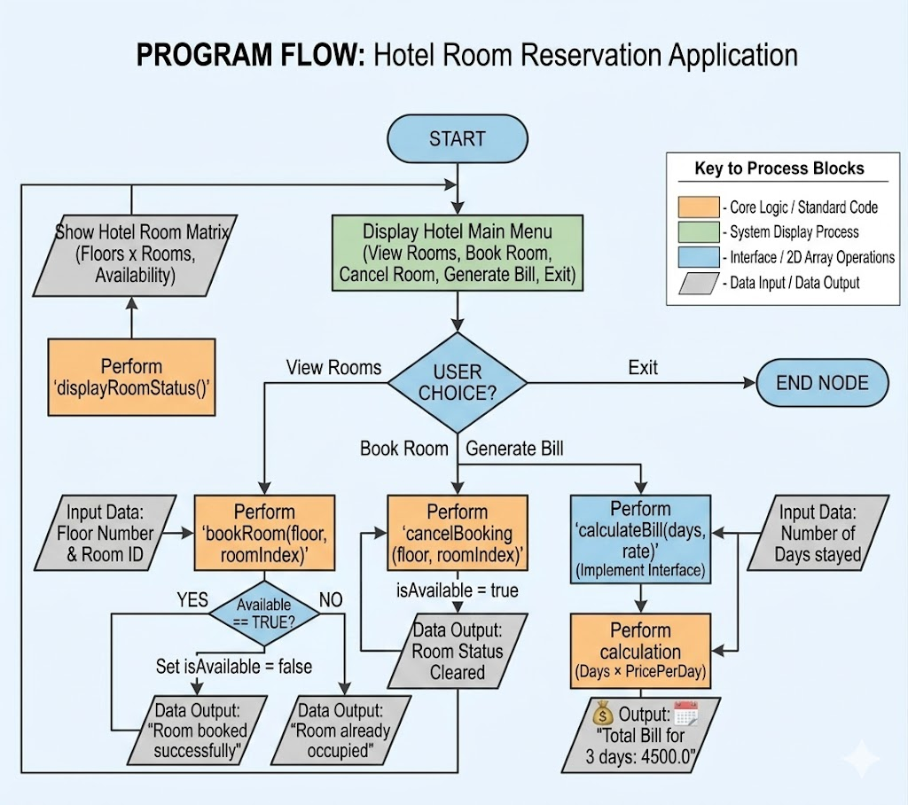

Class Diagram

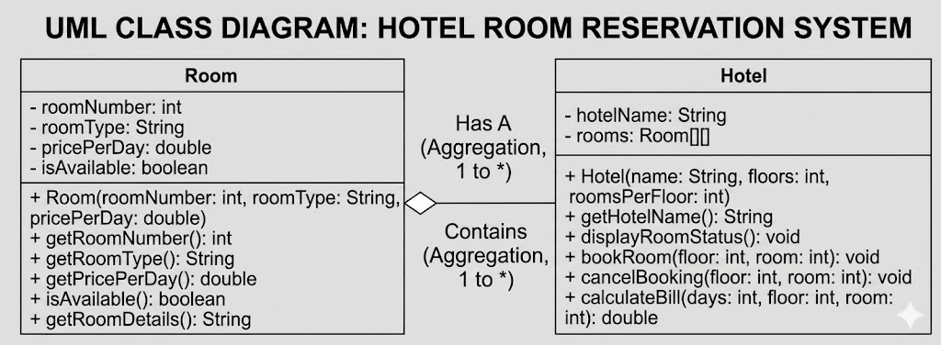

Class Name
Service Interface
- Methods:
- calculateBill(int days, double rate) (Abstract method to define billing rules)
Room Class
- Variables:
- int roomNumber
- String roomType (Single/Double/Deluxe)
- double pricePerDay
- boolean isAvailable
- Methods:
- Constructor (int roomNumber, String roomType, double pricePerDay)
- getRoomNumber()
- getRoomType()
- getPricePerDay()
- isAvailable()
- setAvailable(boolean status)
Hotel Class (Implements Service)
- Variables:
- String hotelName
- Room[][] rooms (2D Array to represent Floors and Rooms)
- Methods:
- Constructor (String name, int floors, int roomsPerFloor)
- bookRoom(int floor, int roomIndex) (Logic to check availability and mark as occupied)
- cancelBooking(int floor, int roomIndex) (Logic to mark room as available)
- displayRoomStatus() (Logic to print the 2D matrix of rooms)
- calculateBill(int days, double rate) (Overridden method to calculate days * rate)
Main Class (HotelApp)
- Methods:
- main() (Entry point to initialize the Hotel, perform bookings, cancel bookings, and display results)

Implementation
The Hotel Room Reservation Application is implemented using a modular approach that focuses on abstraction and structured data storage:
- Service Interface: This is the core of the system's abstraction. It defines the calculateBill() method, ensuring that any class handling payments follows a strict standard. It separates the "rules" of billing from the actual room management logic.
- Room Class: This class acts as a template for every room in the hotel. It uses encapsulation to protect sensitive data like pricePerDay and isAvailable. By keeping these variables private and using getter/setter methods, we ensure that a room's status can only be changed through proper booking channels.
- Hotel Class: This class manages the hotel's infrastructure using a 2D Array (Room[][]). Each row represents a floor, and each column represents a room on that floor.
  - bookRoom(): This method accesses a specific index in the 2D array and checks the isAvailable boolean. If available, it flips the state to false.
  - calculateBill(): This implements the logic from the Service interface to multiply the duration of stay by the room's specific rate.
- HotelApp (Main Class): This acts as the controller. It initializes the hotel matrix, simulates user interactions (booking/canceling), and prints the final room status to the console.

Sample Input/Output

Terminal Output:

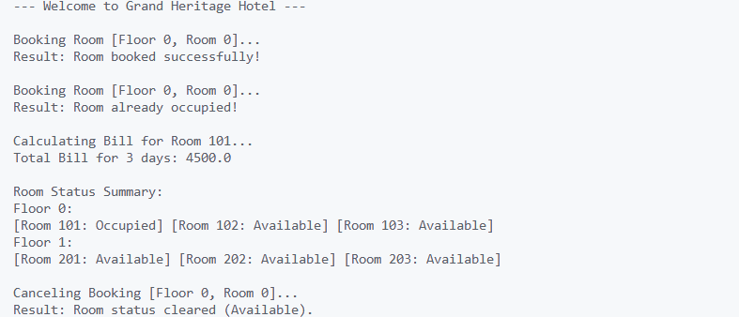

Future Enhancements
- Dynamic Room Pricing: Implement logic to change prices based on "Peak Season" or "Weekend" rates using the Service interface.
- Database Persistent Storage: Integrate JDBC/MySQL to save the room matrix so that booking data isn't lost when the program restarts.
- GUI Dashboard: Use JavaFX to create a visual "Hotel Map" where users can click on a room icon to book or view details.
- Customer Profiles: Add a Guest class to store customer names, IDs, and booking history linked to specific room objects.
- Tax & Amenities Logic: Expand the calculateBill method to include GST, room service charges, and laundry fees for a more realistic invoice.

Gantt Chart: Project Timeline
1. Planning & Structure
The following Gantt chart outlines the rapid 7-day development schedule for the Hotel Room Reservation Application. A structured approach is essential to successfully transition from understanding room inventory logic to a final, polished application. The first two days are dedicated to establishing the project's foundation: Requirement Analysis ensures we understand floor/room matrix operations and Class Design (UML) establishes the core relationships, specifically the Aggregation (HAS-A) link between the Hotel and Room classes and the Implementation of the Service interface.
2. Time Management
The Gantt chart uses a milestone-driven schedule to ensure systematic execution:
- Initialization (Days 1–2): Finalizing the 2D array dimensions (Floors/Rooms) and defining the attributes for the Room class and Service interface.
- Implementation (Days 3–5): Focused coding of the Room class, followed by the complex 2D array logic in the Hotel class (bookRoom, displayRoomStatus), and implementing the calculateBill method using interface rules.
- Validation (Day 6): Testing the system to ensure that booking a room correctly updates the availability status and that billing correctly handles the number of days stayed.
- Finalization (Day 7): Preparing final documentation, screenshots of the terminal output, and presentation materials.

Project Schedule Table
The following table represents the structural breakdown of this project across a concise seven-day development cycle.
Legend: ■ Purple = Task Active | □ White = Task Inactive
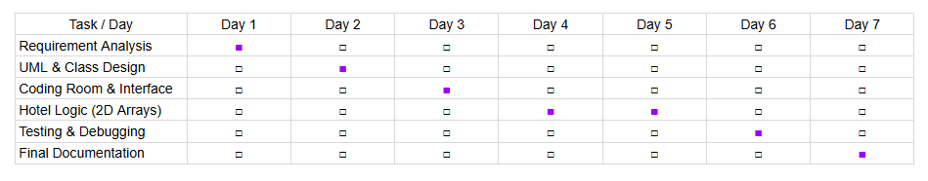

Conclusion
The Hotel Room Reservation Application project successfully demonstrates how complex real-world logic can be simplified using Object-Oriented Programming (OOP). By using a 2D Array to represent floors and rooms, we have moved beyond basic lists to a more structured way of managing data that mirrors the physical layout of a building.
Through the completion of this project, I have mastered several critical programming concepts:
- Abstraction and Interfaces: Using the Service interface to define a standard for financial calculations without cluttering the main logic.
- Encapsulation: Protecting room data to ensure that availability and pricing are only modified through authorized methods.
- Multi-Dimensional Data Handling: Navigating and managing a matrix of objects (2D Array) to track real-time status changes.
- State Management: Implementing logic that successfully toggles a room between "Available" and "Occupied" based on user actions.
Ultimately, this application provides an efficient, automated solution for hotel management, reducing manual errors in room tracking and billing. It serves as a solid foundation for more advanced features like database connectivity or a graphical dashboard.

References
Book Format
[1] H. Schildt, Java: The Complete Reference, 12th ed. New York: McGraw-Hill, 2021.
[2] K. Sierra and B. Bates, Head First Java, 3rd ed. Sebastopol: O'Reilly Media, 2022.
Website Format
[3] Oracle, "Java Interface Documentation," Oracle. [Online]. Available: https://docs.oracle.com/javase/8/docs/api/java/lang/reflect/Proxy.html
[4] GeeksforGeeks, "Multidimensional Arrays in Java," [Online]. Available: https://www.geeksforgeeks.org/multidimensional-arrays-in-java/
Journal Article Format
[5] S. Mohapatra, "Modernizing Hospitality Management through Object-Oriented Systems," International Journal of Software Engineering, vol. 14, no. 3, 2025.
Conference Paper Format
[6] R. Mehta, "Design Patterns for Automated Reservation Systems," in Proc. International Conference on Information Technology and Management (ICITM), 2024.

